The Use of Web Techniques for Revising RCT PILs

The Use of Text Analytics & Crowdsourcing to Acquire, Measure and Analyse Public Reviews on Patient Information Leaflets for Randomized Clinical Trials.



MSc. Santos Sanchez F.

J.C.Wyatt@soton.ac.uk

Prof Wyatt J.

J.C.Wyatt@soton.ac.uk

Prof Tiropanis T.

t.tiropanis@southampton.ac.uk

Prof Geraghty A.

a.w.geraghty@soton.ac.uk

## Summary

Clinical trials have become a corner stone (Lovato, Hill, Hertert, Hunninghake, & Probstfield, 1997) for identifying high-quality interventions in the health-care systems of developed countries. They enable researchers to compare the effects of new drugs and treatments against those that are currently employed, to improve the health-care of the general population by developing new guidelines and practices (NHS, 2017). On the other hand, their very nature implies a risk for the patients who choose to participate, of either receiving a sub-optimal treatment or suffering previously undiscovered side-effects (Moore & Savage, 2002). Thus, it is of great importance to ensure the patient is aware of the risks and to enforce ethical practice during recruitment (MRC, 2016).

Therefore, the development of Patient Information Leaflets (PILs) which are able to inform patients about essential trial features is one of the core tasks for any UK clinical trial. The current process for clinical research is based on the NHS proportionate approach to consent (HRA, 2017), which enables most PILs for Randomised Controlled Trials (RCTs) to be designed by filling on template forms provided by the HRA and be reviewed by an Ethics Panel as part of the research submission. Nonetheless, even if this information is recognized as an essential part of any RCT by the HRA (NHS, 2017), several independent studies in the last decade have consistently found most PILs have serious issues on informing patients despite fulfilling the legal requirements and following NHS recommended guidelines and templates (Reinert, et al., 2014) (Gillies, Huang, Skea, Brehaut, & Cotton, 2014) (Poplas-Susíc, Klemenc-Ketis, Kersnik, & others, 2014) (Knapp, Raynor, Silcock, & Parkinson, 2011) (Nicholls, Hankins, Hooley, & Smith, 2009). Several different approaches have been sought to address these issues from employing quantitative content analysis of the PILs’ text to engaging with Patient and Public Involvement (PPI) groups. However, these topics have remained a research priority as evidenced by The Health Research Board Trials Methodology and Networks (TMRN) work with the James Lind Alliance and the TrialForge to setting priorities for trial recruitment research (Healy, et al., 2018). Specifically, identifying which information should be communicated to patients, assessing the effect of PPI collaboration on recruitment rates and finding the best methods to deliver information are among the top five questions identified by this JLA priority-setting panel (Healy, et al., 2018).

Therefore, it is our intention to build a tool that supports the quantitative assessment and comparison of several techniques effects on PIL readability and ease of understanding of essential trial features. Our work explores the use of textual characteristics of PILs for clinical trials, using thematic analysis on PIL comments from a PPI group, employing quantitative readability metrics to identify sentences that are too hard to understand by general audiences, the use of quantitative procedures to assess the readability of the document and the health literacy skill of the readers, employing Amazon crowdsourcing to rewrite sentences that were deemed too hard to understand, the use of a Web platform to collect, link and present the data generated during the revision process by members of the public.

## Preface

### Contributions & Acknowledgements

I dedicate this work to my father who taught me to think for myself and question the world, and whose unconditional support made possible the realization of this dream. I also wish to thank my mother and siblings whom I have dearly miss every day of this five years, and my supervisors who have been with me when the though parts have come and I had lost my motivation. In addition, I wish to recognize the support of the Mexican government and the University of Southampton for providing the necessary economic funds for this research.

### Scope

This thesis has been organized in three general parts describing the research process to consolidate the different approaches into creating PILs that are easier to understand by public audiences by employing Web techniques. In the first part of the thesis we focus our research into assessing the essential characteristics of the PILs’ texts, determining their emotive composition and the feasibility of employing diverse techniques to assess their contents. In the second part of the thesis we explore the themes and composition of public comments given to PILs with low readability and poor recruitment rates. In the final part of the thesis we evaluate the feasibility of both employing a Web platform to collect, associate, analyse and present public feedback on PILs and the use of crowdsourcing to revise PILs sentences that are deemed too hard to understand.

### Publication

PhD Symposium Paper: A Web Platform for Public Involvement Reviewing Patient Information Leaflets for Randomized Clinical Trials in the UK.

PhD Symposium Paper: Analysis of Public Comments on Patient Information Leaflets as a Measure of Quality Perception and Patient Understanding.

Unpublished Full Paper (16 pages): Analysing Public Feedback on Patient Information Leaflets: Reviewer Perception of Quality and Objective Understanding of the Information.

## Table of Contents

Summary 2

Preface 3

Contributions & Acknowledgements 3

Scope 3

Publication 3

Table of Contents 4

Table of Figures 6

Chapter 1: Patient Information Leaflets for Randomized Clinical Trials 7

The importance of Patient Information PILs 8

Procedure for Designing PILs for RCTs in the UK 9

PIL Quality Issues 9

Chapter 2: Methods for Increasing the Readability and Understandability of Textual Information 11

NHS Proportionate Approach to the Process of Seeking Consent 11

HRA PIL Guidance & the Use of Templates 11

Employing Patient & Public Involvement Groups 11

Quantitative Analysis of Text 11

Readability Indexes 11

Web Text Analysis 11

Analysis of Sentiment and Emotion in Text 12

Maximization of Information Delivery a Psychological approach to Leaflet Design 13

Clustering techniques for identifying core characteristics 17

Chapter 3: Analysis of the characteristics of PILs text 18

Research Questions 18

Aims 18

Justification 18

Background & Rationale 19

Methods 19

Sample & Recruitment 19

Limitations 20

Procedure 20

Measures & Analysis 21

Results 22

Discussion 27

Strengths & Weaknesses 27

Chapter 4: Analysing Public Comments on PILs with Low Readability and Poor Recruitment Rates. 28

Summary 28

Research Questions 28

Aims 28

Background & Rationale 28

Methods 29

Sample 30

Recruitment 30

Procedure 30

Analysis & Metrics 32

Results 35

Sample detail 35

Comment analysis: How many reviewers are needed to obtain a good coverage of comments? 36

Comment analysis: Classification and coding 40

Association between the percentage of correct answers, PIL quality grade and the comments provided by the reviewers. 53

Demographic factors associated with the PIL quality grades 55

Demographic factors associated with the reviewers’ understanding of trial features 59

Validation analysis: Lexicon polarity vs manual annotation 61

Conclusions 63

Chapter 5: Assessing the feasibility of using a Web Platform and Amazon Crowdsourcing to Revise the Text of RCT PILs. 64

Research Questions 64

Aims 65

Background & Rationale 65

Methods 66

Employing a Web platform to collect public feedback on PIL text. 66

Using the Cloze procedure to identify jargon terms and structural problems in the PIL sentences. 66

Identifying the required health literacy skill needed to revise PIL sentences 66

Assessing the learning and fatigue effects when revising PILs sentences 66

Assessing the viability of the proposed revisions under the PIL authors perspectives 66

Chapter 6: Research Schedule 67

Bibliography 67

## Table of Figures

Figure 1 Plutchik’s Wheel of Emotion (Plutchik, 1984) 13

Figure 2 The components of Memory (Jansson-Boyd, 2010) 14

Figure 3 The elements of learning (Jansson-Boyd, 2010) 16

Figure 4 Average number of words in news articles and PILs 22

Figure 5 Average percentage of lexicon words identified as emotional 23

Figure 6 Comparison of PILs with news articles from 3 sources 24

Figure 7 Comparison of PILs recruiting well (at least 80% of planned sample) and badly 24

Figure 8 Percentage of words related to each emotion category in the news articles & PILs 25

Figure 9 Percentage of words related to Positive and Negative sentiments in the control documents & PILs 26

Figure 10 Percentage of words related to each emotion category in love letters, hate mail, suicide notes & PILs (MSc research) 26

Figure 11 Comparison of the number of general and specific comments given to each PIL 36

Figure 12 Contribution of specific comments per reviewer 37

Figure 13 Distribution of specific comments taking the full sample of reviewers 37

Figure 14 Distribution of comments when excluding reviewers who did not gave any specific comment 38

Figure 15 Association between PIL quality grade and the percentage of correct EQIP answers 54

Figure 16 Association between the number of comments on specific sections and the percentage of correct EQIP answers obtained by the reviewer 55

Figure 17 Ordinal demographic factors correlated with the PIL quality grade 56

Figure 18 [Boxplot] Quality grades grouped by interest in participating in an RCT 57

Figure 19 [Boxplot] Quality grades grouped by gender 57

Figure 20 [Boxplot] Quality grades grouped by origin 58

Figure 21 Ordinal demographic variables associated with the percentage of correct EQIP answers 59

Figure 22 [Boxplot] Percentage of correct EQIP answers grouped by gender 60

Figure 23 [Boxplot] Percentage of correct EQIP answers grouped by origin 60

Figure 24 [Boxplot] Percentage of correct EQIP answers grouped by interest in participating in an RCT 60

# Patient Information Leaflets for Randomized Clinical Trials

The development of PILs to inform patients about essential trial features is one of the core tasks for any clinical trial run in the UK. This information is commonly presented as patient information PILs, sheets, online documents or videos that complement or enhance the explanations given by the trial recruiters. Currently, these documents are regulated by following the pre-set formats and guidelines on the best practice for medical research set by the Health Research Authority (HRA). Under these guidelines the PILs must have an impact on the participants’ decision if they are to accomplish their primary goal:

“The Participant Information Sheet should support the consent process by helping to ensure that all those who are invited to take part in a research study have been adequately informed” and “should enable potential participants to make an appropriate decision that is right for them” - (MRC, 2016) (MHRA, 2016).

Despite official recognition of the importance of these documents (NHS, 2017), several concerns have been risen about their quality in the last decade. The lack of a rigorous method for assessing the quality of written patient information, materials that are difficult to read (Moult, Franck, & Brady, 2004), inaccurate content (Moult, Franck, & Brady, 2004) (Nicholls, Hankins, Hooley, & Smith, 2009) (Escudero-Carretero, et al., 2013) and insufficient quality on most evaluated categories (e.g. text length, legibility, layout, visual structure) except ethical and legal requirements (Reinert, et al., 2014) are high priority research topics of the BRM-TMRN 2016 study (Healy, et al., 2018).

On the other hand, the fast retrieval, processing and analysis of massive amounts of text have become core activities in our current Web model. These tasks are commonly called as text (data) mining and the set of techniques employed to model and structure the information is referred as text analytics (Association, 2007), (Grimes, 2007). Furthermore, the inherent challenges of working with unstructured data formats have been recognized since the late 50’s:

"...utilize data-processing machines for auto-abstracting and auto-encoding of documents and for creating interest profiles for each of the ’action points’ in an organization. Both incoming and internally generated documents are automatically abstracted, characterized by a word pattern, and sent automatically to appropriate action points." - H.P. Luhn, October 1958 IBM Journal article

This has created many techniques in areas like information retrieval, named entity recognition, disambiguation, co-reference, relationship and content analysis that could reveal valuable insights when applied to the PILs. In this project, we seek to assess if a Web platform can make use of sentiment analysis, readability metrics, crowdsourcing and online recruitment to facilitate Public Involvement when revising Information Leaflets for potential participants of Randomized Controlled Trials. We also explore the effects of adding an information retrieval system (for previous PPI comments and writing guidelines) to form content analysis reports as an enhancement to the feedback normally given by public reviewers when reviewing PILs for low risk trials. The insights that cluster analysis can provide about the inherent relationships present in the documents, employing readability metrics to objectively quantify the difficulty of the documents and using sentiment analysis to detect the opinions and perceptions of the reviewers could greatly enhance the feedback given to a PI designing a new PIL. Thus, we seek to design and assess a Web platform for:

* Collecting public feedback on RCT PILs.
* Employing text analysis and readability metrics to objectively identify sentences that require higher reading skills than the average on general populations.
* Using a Web platform to crowdsource the revision of PIL sentences with low readability.
* Employing the platform to validate the readability of these revisions.

We also provide secondary analysis of the results to assess the association between participant performance, sentence readability and participant reading skill level, and the effects of learning and fatigue on participants who revise the sentences.

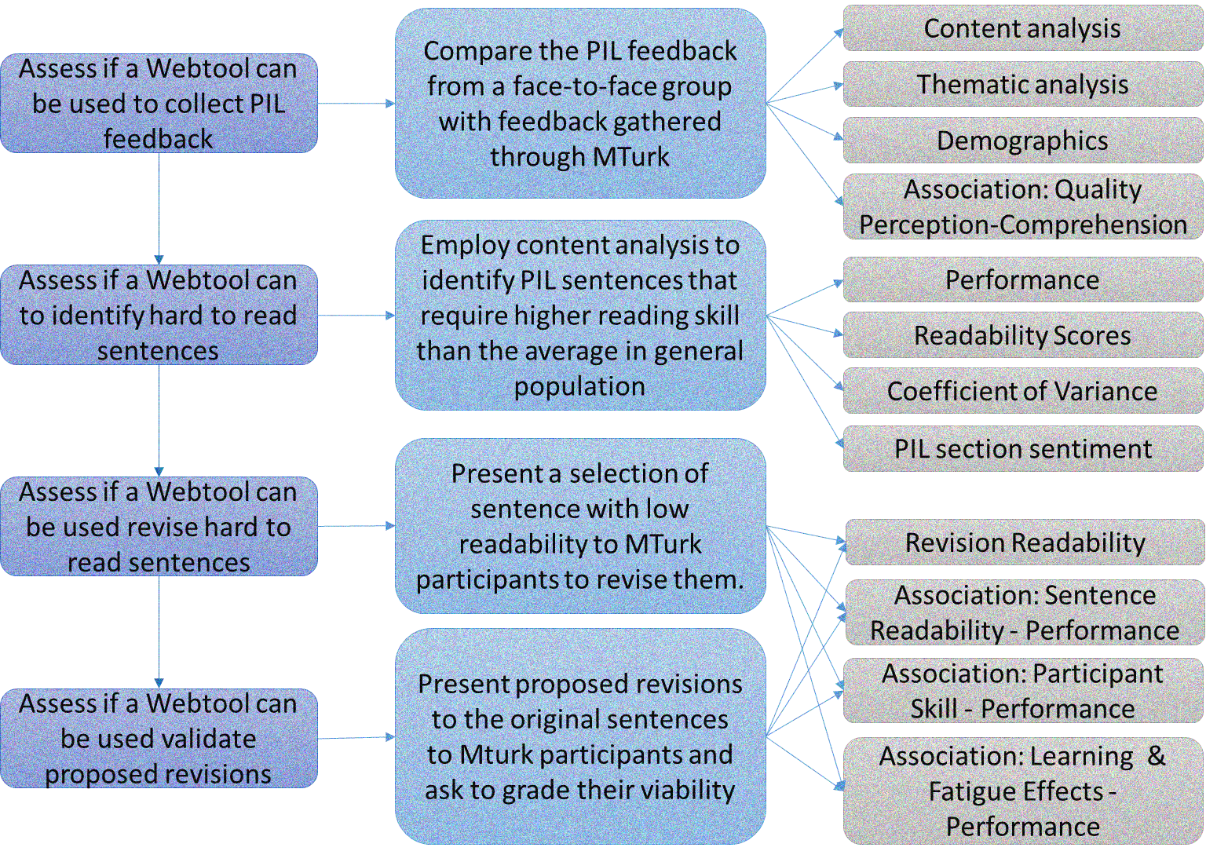

Figure 1 Thesis methodology

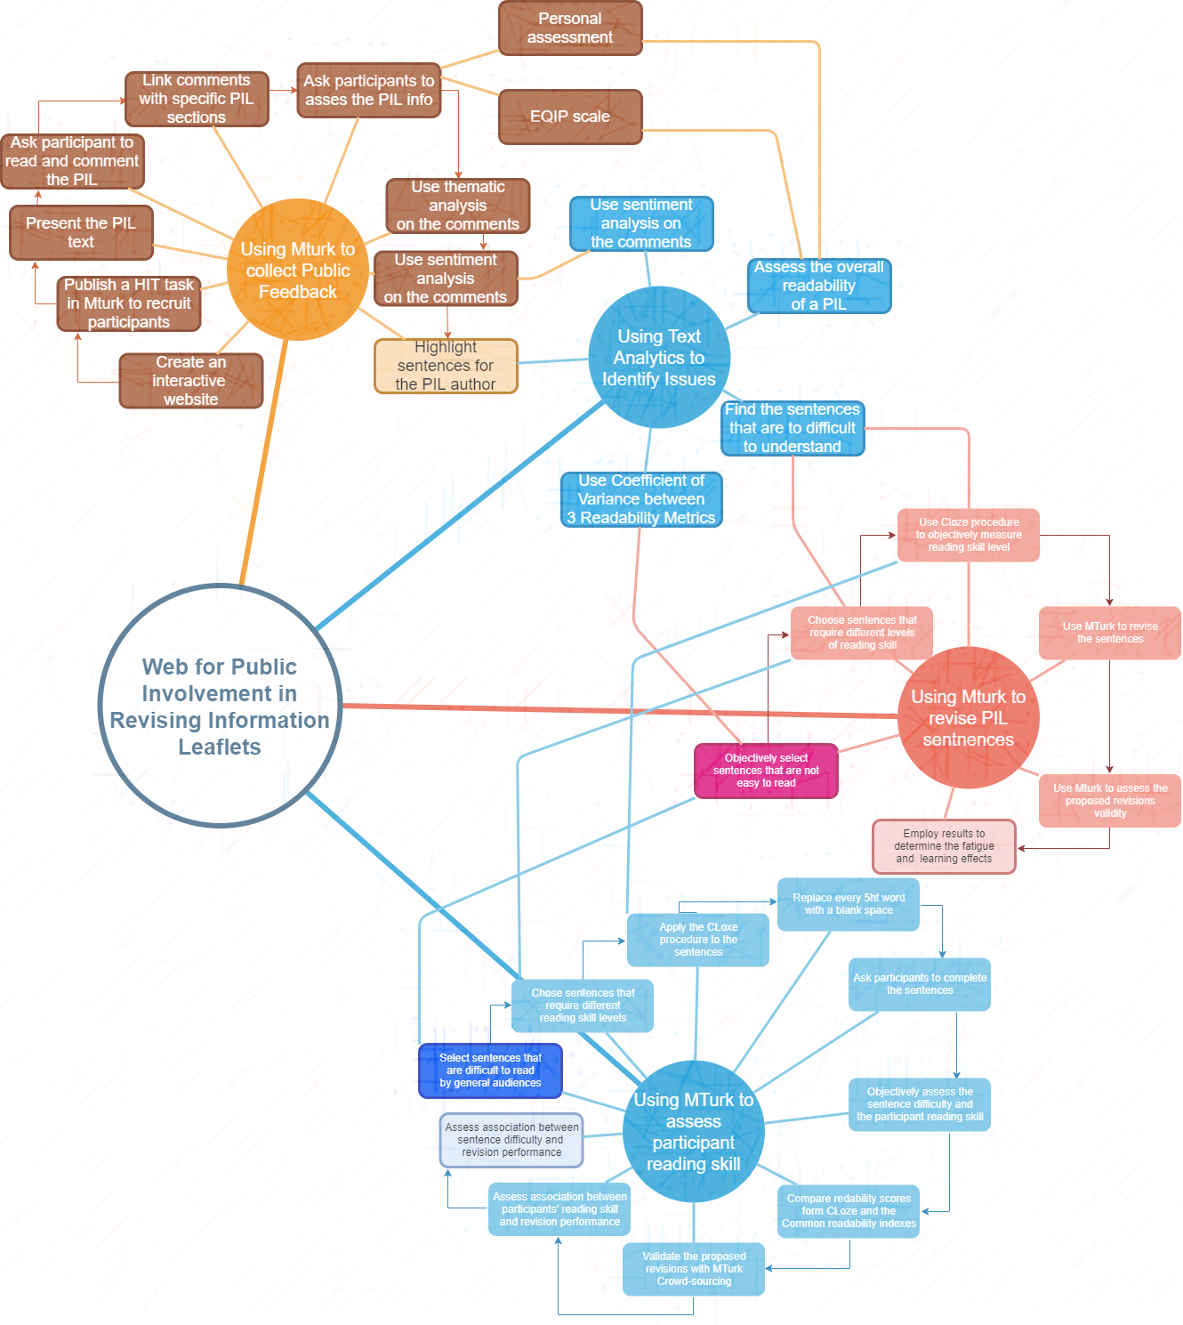

Figure 2 Methodology Diagram

## The importance of Patient Information PILs

I have previously mentioned that providing the patient with information to make an informed decision is a fundamental part of trials in the UK (NHS, 2017). This information generally includes Patient Information PILs, sheets and documents, which “should support the consent process by helping to ensure that all those who are invited to take part in a research study have been adequately informed” and “should enable potential participants to make an appropriate decision that is right for them” (NHS, 2017), MRC. These elements can form a baseline for the different interventions that should be associated with recruitment to RCTs. However, “Despite the recent focus on improving the quality of patient information, there is no rigorous method of assessing quality of written patient information” (Moult, Franck, & Brady, 2004). As has been previously commented, the HRA guidelines encourage the researchers to employ heavily standardized forms and formats with only general advice given in how to describe the RCT consist of considering the “intended audience”, employing “clear language” and to involve potential patients in the drafting of the PIL (MHRA, 2016). This has created a widespread view in the clinical community that the PILs must employ “everyday language” and explain complex words and clinical jargon but employ a “respectful tone” (Charvet-Berard, Chopard, & Perneger, 2008). The following sections explore the general literature on the aspects approached by our research proposal.

## Procedure for Designing PILs for RCTs in the UK

The HRA guidance for “Applying a proportionate approach to the process of seeking consent” (HRA, 2017) , “Consent & Participation Information Sheet Preparation Guidance” (HRA, 2014) and “Consent and Participant Information Sheet Preparation Guidance” (MRC, 2016) gives most of the framework on how to design PILs for RCTs in accordance with UK-wide legal requirements. The HRA guidelines have a focus on applying the principle of proportionality and creating more accessible participant information for clinical trials seeking consent. This particular set of guidelines main focus is to provide guidance for clinical trials in medicinal products (CTIMPs) but it is also commonly applied to clinical trials on devices or other types of interventional/non-interventional research (NIHR, 2014).

The current approach of a proportionate process of seeking consent tries to balance two divergent factors, that seeking informed consent is central to ethical research (HRA, 2017) which implies that potential research participants must be given the necessary information to help them make a decision on participating, and on the other hand, that seeking consent has become a rigid perfunctory procedure (MO., 1998) (Ploug & Holm, 2012) (Tobias & Souhami, 1993) with information sheet that are too long or complex to help the potential participants (Roberts, Prieto-Merino, & Shakur, 2011), and which principal function has become to protect researchers and sponsors from litigation by describing every minor detail (O'Neil, 2003). Thus, the current proportionate approach seeks to implement procedures that correspond to the balance of risk and benefits to avoid lengthy and complex information leaflets. Creating user-friendly information leaflets that contain succinct, relevant, truthful information is the ultimate goal of these guidelines by considering the research nature and complexity, its risks, burdens and potential benefits and the ethical issues that can arise from it (HRA, 2017). Therefore, the closer the research is to current clinical practice, the less detail it needs to cover in its information leaflet, suggesting that in many accounts it will be the *verbal* exchange during the discussion with the potential participant that will be crucial in facilitating the decision (HRA, 2017).

The HRA current guidelines are based on 14 principles from the Medicines for Human Use (Clinical Trials) (HRA, 2017) (MRC, 2016).

1. The rights, safety and well-being of the trial subjects shall prevail over the interests of science and society.
2. Each individual involved in conducting a trial shall be qualified by education, training and experience to perform his tasks.
3. Clinical trials shall be scientifically sound and guided by ethical priciples in all their aspects.
4. The necessary procedures to secure the quality of every aspect of the trial shall be complied with.
5. The available non-clinical and clinical information on an investigational medicinal product shall be adequate to support the proposed clinical trial.
6. Clinical trials shall be conducted in accordance with the principles of the Declaration of Helsinki.
7. The protocol shall provide for the definition of inclusion and exclusion subjects participating in a clinical trial, monitoring and publication policy.
8. The investigator and sponsor shall consider all relevant guidance with respect to commencing and conducting a clinical trial.
9. All clinical information shall be recorded, handled and stored in shuch a way that it can be accurately reported, interpreted and verified, while the confidentiality of records of the trial subjects remains protected.
10. Before the trial is initiated, foreseeable risks and inconveniences have been weighed against the anticipated benefit for the individual trial subject and other present and future patients. A trial should be initiated and continued only if the anticipated benefits justify the risks.
11. The medical care given to, and medical decisions made on behalf of, subjects shall always be the responsibility of an appropriately qualified doctor or, when appropriate, of a qualified dentist.
12. A trial shall be initiated only if an ethics committee and the licensing authority comes to the conclusion that the anticipated therapeutic and public health benefits justify the risks and may be continued only if compliance with this requirement is permanently monitored.
13. The rights of each subject to physical and mental integrity, to privacy and to the protection of the data concerning him in accordance with the Data Protection Act are safeguarded.
14. Provision has been made for insurance or indemnity to cover the liability of the investigator and sponsor which may arise in relation to the clinical trial.

These principles and common law require that participants “be informed, in broad terms, of the nature and purpose of the research and the material risks, and benefits and reasonable alternatives” (HRA, 2017)[1],[2] . Therefore, the core information about a trial should be provided in a succinct form, paying attention to the way it is conveyed, using language that most people can understand and considering the layout and format to aid the explanation.

These has lead the HRA to consider that the amount of information that has to be provided to the participants outside the core information (research nature, significance, implications and risks) when seeking their participations must vary in accordance with the balance between risk and benefits of the research e.g. practical information of the trials (timings, payment of travel expenses, etc.) would only be needed if it has implications on the participant decision to join the trial (need for abstinence, significant drug interactions, etc.).

The MHRA categorises three levels of trial risk, where pragmatic trials are considered an especial subset within these guidelines as they generally do not involve additional risk to those inherent of current care practices and therefore make it possible to often simplify the necessary information in a single, short participant sheet. Pragmatic trials, also known as ‘simple trials’, ‘comparative effectiveness trials’, ‘non-interventional trials’ or ‘low-intervention trials’, are defined as trials that do not involve interventions beyond the normal care of the patient, rather they focus on comparing the effects of accepted/licensed interventions or therapies in current clinical practice.

|  |  |
| --- | --- |
| **Trial Categories based upon the potential risk associated with the IMP** | **Examples of types of clinical trials** |
| ***Type A****: no higher than* that of standard medical care | Trials involving medicinal products licensed in any EU Member State if: • they relate to the licensed range of indications, dosage and form, or • they involve off-label use (such as in paediatrics and in oncology etc.) if this off-label use is established practice and supported by sufficient published evidence and/or guidelines |
| ***Type B****: somewhat higher* than that of standard medical care | Trials involving medicinal products licensed in any EU Member State if: • such products are used for a new indication (different patient population/disease group) or • substantial dosage modifications are made for the licensed indication or • if they are used in combinations for which interactions are suspected Trials involving medicinal products not licensed in any EU Member State if • the active substance is part of a medicinal product licensed in the EU (A grading of TYPE A may be justified if there is extensive clinical experience with the product and no reason to suspect a different safety profile in the trial population) |
| ***Type C****: markedly higher* than that of standard medical care | Trials involving a medicinal product not licensed in any EU Member State (A grading other than TYPE C may be justified if there is extensive class data or pre-clinical and clinical evidence) |

Pragmatic trials involving non-drug interventions only need to comply with the common law, research involving medicine also need to comply with “The Medicines for Human Use (Clinical Trials) Regulations” (UK Parliament, 2004) referred as Clinical Trial Regulations. The Clinical Trial Regulations also apply to pragmatic trials where the research protocol is used to decided what drug is given to the patients instead of their doctors or other healthcare professional as part of their clinical care.

|  |  |
| --- | --- |
| **Trial Categories Based on Potential Risk** | **Required information** |
| ***Type A (Pragmatic Trials)****: no higher than* that of standard medical care | Broad description of:   * Research nature and purpose * Material risks and benefits * Reasonable alternatives |
| ***Type B & C (CTIMPs[3])****: somewhat higher* than that of standard medical care | The Clinical Trials Regulations require potential participants to be informed of:   * Nature of the research * Significance of the study * Potential implications and risks * Must have an interview with a member of the investigation team where they can discuss the objectives, risks and inconveniences of participating in the trial |

The HRA guidelines include a PIL template for RCTs (HRA, 2017) to be used and adapted for pragmatic trials, and Type B & C CTIMPs, which is also commonly employed as a reference for other research studies (Annex A). To complement these principles the HRA “Consent & Participant Information Sheet Preparation Guidance” (HRA, 2014) provides further guidance on how to created good information for potential participants by:

1. Taking notice that the information required to enable potential participants’ decision will vary in accordance with the nature and burden of the research.
2. Creating PILs as simple and short as possible while including all necessary information to enable the participant decision.
3. Setting the importance of your study, designing a good title that provides a consice summary of the study with words your participants can understand.
4. Employing an invitational style, create a PIL that is a polite invitation to participate, setting potential advantages, risks and alternatives.
5. Do not employ passive voice.
6. Employing plain English and avoiding clinical terminology (jargon) when possible.
   1. Remember your audience
   2. Use short words and sentences
   3. Use lay language and familiar words to your audience
   4. The language should not be more difficult than medicine leaflets or tabloid newspapers
   5. Participants should understand the PIL in the first reading
   6. All potential participants should understand your PIL
   7. Limit sentences to no more of 20 words
   8. Do not include more than one idea per sentence. If the next sentence does not follows the previous one, start a new paragraph
   9. Avoid obscure or commonly misunderstood words (dual or nuanced meanings e.g. drugs and diet)
   10. Avoid more than two hard words in a sentence unless you are explaining a term and consider employing acronyms for repeated use. A hard word is a word that is a technicism, jargon, uncommon, long or with many syllables.
7. Use a format that support understanding
   1. Use short heading that stand out
   2. A question-answer format is effective
   3. Use large type size (16 pts) if you are recruiting elderly subjects
   4. Avoid unbroken sections of text or long lists
   5. Use bullet points for lists
   6. Avoid justified text
   7. Use bold lower case for emphasis
   8. Consider the use of multimedia to support the consent process (CDs, DVDs, etc.)
8. Consider the use of diagrams to facilitate the explanation and discussion with the participant
9. Consider the participant perspective, address issues that may be very important to the participants’ decision (e.g. Will I have to take time off to take part? How many times will I need to attend?)
10. Be clear about expected risks and benefits
11. If you are recruiting two or more groups of participants, consider creating different PILs to address their particular concerns
12. Test your PIL with and appropriate group of people (Patient or Public groups), you do not need NHS Research Ethics Committee (REC) approval to test your consent documents

Additional guidance is given in the document for Adults who are not able to consent by themselves, children and young people and emergency research. These topics fall outside the scope of this research and thus would be omitted.

## PIL Quality Issues

Most of the recent research on PILs have focused on determining their quality or developing an objective method of measuring their quality, in response to Moult (Moult, Franck, & Brady, 2004). These studies have commonly found that the quality of the PILs is not optimal, often requiring a higher reading age than recommended and containing inaccuracies (Moult, Franck, & Brady, 2004) (Nicholls, Hankins, Hooley, & Smith, 2009) (Escudero-Carretero, et al., 2013). It is also a common perception in different research stakeholders (recruiters, nurses, doctors, researchers and ethic committee members) that PILs have no actual influence on the patient decision to participate and are in most cases not read or remembered (Poplas-Susíc, Klemenc-Ketis, Kersnik, & others, 2014). This brings into question if the PILs are fulfilling their role of supporting the patient decision-making process, as detailed by UK clinical regulations (NHS, 2017). This section explores some of the most commonly employed methods to assess PIL quality.

The most common assessment criteria to evaluate the quality of PILs are readability metrics, which are employed by virtually all the studies in the area in one form or another (Reid, et al., 1995) (Knapp, Raynor, Silcock, & Parkinson, 2011) (Escudero-Carretero, et al., 2013) (Gillies, Huang, Skea, Brehaut, & Cotton, 2014) (Reinert, et al., 2014). The particular metrics selected by each study vary from simple measurement of length (in either words or pages) or font size (Knapp, Raynor, Silcock, & Parkinson, 2011) to the employment of specialized formulas and instruments like the Flesch-Kincaid (Gillies, Huang, Skea, Brehaut, & Cotton, 2014) or Flesch-Formel (Reinert, et al., 2014) coefficients and the SMOG/INFLESZ scores (Escudero-Carretero, et al., 2013). In addition, Knapp (Knapp, Raynor, Silcock, & Parkinson, 2011) carried out qualitative work to measure reading times, interest in the topics, and comprehension of the topics. The readability results of these studies were similar in all cases, concluding that the PILs required higher reading skills than those recommended by the guidelines (Nicholls, Hankins, Hooley, & Smith, 2009) (Gillies, Huang, Skea, Brehaut, & Cotton, 2014) (Reinert, et al., 2014). Reinert’s study on neuro-oncology phase III trial PILs (Reinert, et al., 2014) determined that five of the nine PILs analysed required graduate levels to be read and understood.

Other characteristics employed by Reinert to determine the quality of the PILs were the page layout, and evaluations of the ethical and legal requirements, and scientific and social evidence (Reinert, et al., 2014). For the evaluation of the layout, four aspects were considered: the use of subheadings, correspondence between the heading topics and subheadings, the inclusion of a study process flow-chart and the quality of tables and illustrations. According to Reinert, evaluation of the ethical and legal requirements was done by employing a checklist for informed consent created by Harnischmacher. A questionnaire was created to assess the social evidence (PIL provides answers to patients’ frequently asked questions) based on selected items on the Patients’ Frequently Asked Questions, while the assessment of scientific evidence was done in accordance to the DISCERN criteria (Reinert, et al., 2014). Finally, Gillies’ study employed qualitative analysis to assess the degree of support that the PILs provide to the patients decision-making process (Gillies, Huang, Skea, Brehaut, & Cotton, 2014)**.**

The results provided by these studies were uniform across all authors. The patient information PILs, sheets and documents were suffering from severe deficiencies in their quality, which could affect their role in supporting patients to make a decision. Nicholls’ survey on PILs for skin cancer found that all but one PIL required education above primary level. A qualitative study on drug PILs (Poplas-Susíc, Klemenc-Ketis, Kersnik, & others, 2014) determined that the patients do not read the full PILs and consider the language too scientific.

An RCT to evaluate the use of user testing in the design of a PIL (Knapp, Raynor, Silcock, & Parkinson, 2011), found that current patient information sheets are not fit for purpose and may not have enabled valid consent by evaluating the ability of the readers to find and understand facts. Knapp also found that employing user testing could dramatically improve the quality of the PIL: “66% who read the revised PIL showed understanding of all aspects, compared to 15% of those who read the original” (Knapp, Raynor, Silcock, & Parkinson, 2011).

Reinert’s results show that “All patient informed consent documents were of insufficient quality in all categories except that ethical and legal requirements were fulfilled” (Reinert, et al., 2014), and hypothesises that there may exist a conflict between the need to inform about technical details, employ basic language and the legal requirements when designing a PIL. These observations are supported by Gillies study that found the PILs provided for trials on UK Clinical Trial Unit websites did not support good quality decision-making (Gillies, Huang, Skea, Brehaut, & Cotton, 2014).

# Methods for Increasing the Readability and Understandability of Textual Information

## NHS Proportionate Approach to the Process of Seeking Consent

The NHS proportionate approach to the process of seeking consent is briefly described in the previous section when we defined the current process to creating PILs for RCTs. In this section we focus on the implications such an approach has had in our current RCT PILs. To remember, the proportionate approach main objective is to create better information for potential participants by adjusting the level of detail that must be included based on the balance between the benefits and risks the trials has over current care practice for the patient.

### HRA PIL Guidance & the Use of Templates

The HRA provides a PIL template for medicinal clinical trials that can be adjusted to the requirements of type A, B, and C trials (HRA, 2017). This template is also recommended for other types of clinical research (HRA, 2017).

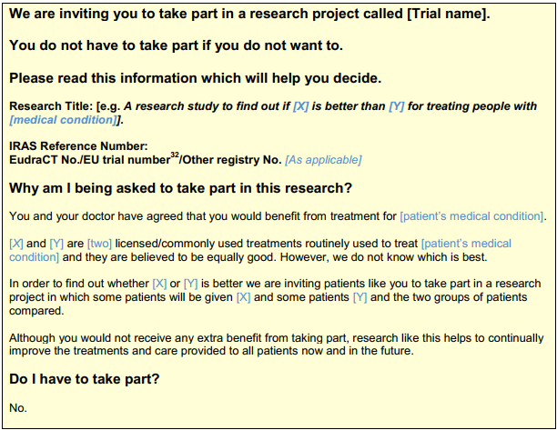

Figure 3 HRA PIL Template Part1

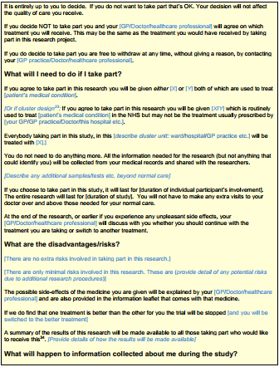

Figure 4 HRA PIL Template Part2

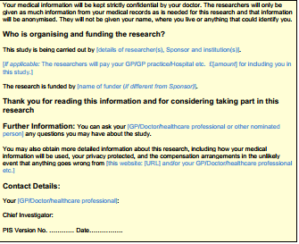

Figure 5 HRA PIL Template Part3

In accordance with the proportionate approach the amount of detail included in each of the template sections must correspond to the level of risk the participant may face. The HRA guidelines recognize three levels of risks for clinical trials, type A when there is no additional risk than the normal care to the patient, type B when participation inherently includes additional risks to the patient than those expected from current care, and type C when there is significant risk to the patient. The form provided by the HRA addresses the requirement of the common law and the UK Clinical Trial Regulations (HRA, 2017) (UK Parliament, 2004):

* Describe the nature and purpose of the research
* The significance of the study
* The potential implications, risks and benefits
* Reasonable alternatives

As a set of 6 questions directed to the participant:

* Why am I being asked to take part in this research?
* Do I have to take part?
* What will I need to do if I take part?
* What are the disadvantages/risks?
* What will happen to information collected about me during the study?
* Who is organizing and funding the research?

It also provides a template for practical information about the trial:

* Research title
* IRAS reference number
* Other registry number
* Lead researcher
* Research funder
* Contact details
* Link for further information
* PIL version
* Date

The amount of detail on each PIL would depend on its risk classification, type A research studies (pragmatic trials) would be able to have greater simplification often covering all relevant topics in a single page, while type B and C trials need to provide additional practical information when this information may have a direct impact on the potential participant decision (e.g. need for abstinence).

The HRA proportional approach to consent has facilitated the creation of less cluttered and overwhelming PILs for clinical trials with low-risk for the patients. On the other hand, it has also induced a perfunctory adherence by clinical researchers on pragmatic trials and has sown the idea that is the verbal discussion with the participants that is crucial to the potential participant decision among the assessing bodies (HRA, 2017). This has brought many cases were PILs for pragmatic trials are approved even when containing readability issues as not enough focus is given to assess their information quality.

### Employing Patient & Public Involvement Groups

The HRA “Consent and PIS Guidance” (HRA, 2014) guidance encourages the clinical researchers to test their PIL with appropriate Patient or Public groups, citing that doing so can help ensure that:

* The document employs appropriate language
* The style and format aids understanding
* The document covers the relevant risks and benefits to the potential participants.

While there is no need to obtain NHS Research Ethics Committee (REC) approval to test the PIL, this may not be as simple task as it appears. The current guidance on involving the public on clinical research is approached in “Patient and Public Involvement in Health and Social Care Research” (NIHR, 2014) and in the INVOLVE website (NIHR-INVOLVE, 2018).

In accordance with INVOLVE definition of public involvement, this is “research that is carried out with or by members of the public rather than to, about or for them” (NIHR-INVOLVE, 2018). In this definition the term public can include patients, potential patient, carers and people who use health and social care services, but seeks to differentiate public involvement from other activities. Under the Involve definition public involvement is not raising awareness of research, sharing knowledge or engaging in dialog with the public. It also does not refer to recruitment of patients or members of the public as participants in research. This means, that while the researchers may engage a Patient or Public Involvement (PPI) group to revise their PIL, assessing the participants understanding of the PIL information falls outside the current definition provided by INVOLVE.

In accordance with the NIHR guidelines for PPI (NIHR, 2014) the institute may ask to “applications that are technically excellent” to engage a PPI group before granting funding to the research, it also states that the main focus of the NIHR PPI activities since 2006 has been to support public involvement in the commissioning process of national research programmes and that it expects all applications are equally committed to PPI.

The “Patient and Public Involvement Payment” guidance (NHIR-SPCR, 2017) for PPI groups is to offer a contributor a payment or “involvement fee” and reasonable travel expenses. It defines public contributors as members of the public (including patients, potential patients, carers and people who uses health and social services) who are being asked to provide a public perspective and are not undertaking the task as part of their full time employment.

|  |  |
| --- | --- |
| Fee | Description |
| **£25** | For involvement in a task or activity requiring little or no preparation and which equates to approximately one hour of activity or less.   * For example, participating in a teleconference or advisory group, or reviewing a short document/lay summary. |
| **£50** | For involvement in a task or activity likely to require some preparation and which equates to approximately two hours of activity.   * For example, a teleconference or advisory group with related papers to read or reviewing a few short documents. |
| **£75** | For involvement in a task or activity likely to require some preparation and which equates to approximately half a days of activity.   * For example, a teleconference or advisory group with related papers to read or reviewing a few short documents. |
| **£150** | For involvement in one-off, all-day meetings.   * For example, attending a committee or panel meeting and reading and reviewing related documents. |

Figure 6 PPI Recommended Fees 2017

The recommended fees for PPI contributors range from £25 per person per hour to £150 per day based on the complexity of the required tasks. When this is added to the the proportionality principle of seeking consent leads most pragmatic trials the conclusion that engaging a PPI group is not a viable idea to revise their PILs.

# Bibliography

Adams, H. F. (1916). *Advertising and its mental laws.* The Macmillan Company.

Averill, J. R. (1980). On the paucity of positive emotions. In *Assessment and modification of emotional behavior* (pp. 7-45). Springer.

Blaney, P. H. (1986). Affect and memory: a review. *Psychological bulletin, 99*, 229.

Bollobás, B. (1998). Modern graph theory, volume 184 of Graduate Texts in Mathematics. Springer-Verlag, New York.

Bolls, P. D., Muehling, D. D., & Yoon, K. (2003). The effects of television commercial pacing on viewers' attention and memory. *Journal of Marketing Communications, 9*, 17-28.

Bondy, J. A., & Murty, U. S. (1976). *Graph theory with applications* (Vol. 290). Citeseer.

Bower, G. H. (1992). How might emotions affect learning. *The handbook of emotion and memory: Research and theory, 3*, 31.

Bower, G. H., & Morrow, D. G. (1990). Mental models in narrative comprehension. *Science, 247*, 44-49.

Charmaz, K. (2014). *Constructing grounded theory.* Sage.

Charvet-Berard, A. I., Chopard, P., & Perneger, T. V. (2008). Measuring quality of patient information documents with an expanded EQIP scale. *Patient education and counseling, 70*, 407-411.

Clements, F. E. (1954). Use of cluster analysis with anthropological data. *American Anthropologist, 56*, 180-199.

Darwin, C. (1872). The expression of the emotions in man and animals, New York: D. *Appleton and Company*.

Darwin, C. (1998). *The expression of the emotions in man and animals.* Oxford University Press, USA.

DeWall, C. N., & Myers, D. G. (n.d.). Words Have the Power to Inspire Violence and Peace.

Dixon, T. L., & Linz, D. (2002). Television news, prejudicial pretrial publicity, and the depiction of race. *Journal of Broadcasting \& Electronic Media, 46*, 112-136.

Duriau, V. J., Reger, R. K., & Pfarrer, M. D. (2007). A content analysis of the content analysis literature in organization studies: Research themes, data sources, and methodological refinements. *Organizational research methods, 10*, 5-34.

Eighmey, J., & Sar, S. (2007). Harlow Gale and the origins of the psychology of advertising. *Journal of Advertising, 36*, 147-158.

Ekman, P. (1973). Cross-cultural studies of facial expression. *Darwin and facial expression: A century of research in review*, 169-222.

Ekman, P. E., & Davidson, R. J. (1994). *The nature of emotion: Fundamental questions.* Oxford University Press.

Entman, R. M., & Rojecki, A. (2001). *The black image in the white mind: Media and race in America.* University of Chicago Press.

Escudero-Carretero, M. J., S{\'a}nchez-G{\'o}mez, S., Gonz{\'a}lez-P{\'e}rez, R., Sanz-Amores, R., Prieto-Rodr{\'\i}guez, M. A., & Fern{\'a}ndez de la Mota, E. (2013). Elaboración y validación de un documento informativo sobre adeno-amigdalectomı́a para pacientes. *Anales del sistema sanitario de Navarra*, *36*, pp. 21-33.

Eysenck, M. W. (2012). *Simply psychology.* Psychology Press.

Gillies, K., Huang, W., Skea, Z., Brehaut, J., & Cotton, S. (2014). Patient information leaflets (PILs) for UK randomised controlled trials: a feasibility study exploring whether they contain information to support decision making about trial participation. *Trials, 15*, 62.

Hart, G. (2002). The five W’s of online help systems.

Healy, P., Galvin, S., Williamson, P. R., Treweek, S., Whiting, C., Maeso, B., . . . others. (2018). Identifying trial recruitment uncertainties using a James Lind Alliance Priority Setting Partnership--the PRioRiTy (Prioritising Recruitment in Randomised Trials) study. *Trials, 19*, 147.

Henry, D., Dymnicki, A. B., Mohatt, N., Allen, J., & Kelly, J. G. (2015). Clustering methods with qualitative data: a mixed-methods approach for prevention research with small samples. *Prevention Science, 16*, 1007-1016.

Hilton, M. (2007). Consumers and the state since the Second World War. *The Annals of the American Academy of Political and Social Science, 611*, 66-81.

HRA. (2017, January 17). Appliying a proportionate approach to the process of seeking consent - HRA Guidance.

Jansson-Boyd, C. V. (2010). *Consumer psychology.* Open University Press New York, NY.

Knapp, P., Raynor, D. K., Silcock, J., & Parkinson, B. (2011). Can user testing of a clinical trial patient information sheet make it fit-for-purpose?-a randomized controlled trial. *BMC medicine, 9*, 89.

Kreutzer, M. A., & Charlesworth, W. R. (1973). Infants' Reactions to Different Expressions of Emotions.

Lovato, L. C., Hill, K., Hertert, S., Hunninghake, D. B., & Probstfield, J. L. (1997). Recruitment for controlled clinical trials: literature summary and annotated bibliography. *Controlled clinical trials, 18*, 328-352.

Mello, R. A. (2002). Collocation analysis: A method for conceptualizing and understanding narrative data. *Qualitative research, 2*, 231-243.

Meyer, K. (n.d.). The Four Dimensions of Tone of VOice. Nielsen Norman Group. Retrieved from https://www.nngroup.com/articles/tone-of-voice-dimensions/

MHRA. (2016). Best Practice Guidance on Patient Information Leaflets. MHRA. Retrieved from https://www.gov.uk/government/publications/best-practice-guidance-on-patient-information-leaflets

Mohammad, S. M., & Turney, P. D. (2013). *NRC emotion lexicon.* Tech. rep., NRC Technical Report.

Mohammad, S. M., & Yang, T. W. (2011). Tracking sentiment in mail: how genders differ on emotional axes. *Proceedings of the 2nd workshop on computational approaches to subjectivity and sentiment analysis (acl-hlt 2011*, (pp. 70-79).

Moore, L., & Savage, J. (2002). Participant observation, informed consent and ethical approval. *Nurse Researcher, 9*, 58-69.

Moult, B., Franck, L. S., & Brady, H. (2004). Ensuring quality information for patients: development and preliminary validation of a new instrument to improve the quality of written health care information. *Health Expectations, 7*, 165-175.

MRC. (2016). Consent and Participant Information Sheet Preparation Guidance. NHS. Retrieved from http://www.hra-decisiontools.org.uk/consent/principles-general.html

National Institute for Health Research -NHS. (2014). *Patient and public involvement in health and social care research: A guide for researchers.* NHS.

NHS. (2017). Clinical trials. Retrieved from http://www.nhs.uk/Conditions/Clinical-trials/Pages/Introduction.aspx

Nicholls, S., Hankins, M., Hooley, C., & Smith, H. (2009). A survey of the quality and accuracy of information leaflets about skin cancer and sun-protective behaviour available from UK general practices and community pharmacies. *Journal of the European Academy of Dermatology and Venereology, 23*, 566-569.

O'Donnell, V., & Jowett, G. S. (1986). *Propaganda and persuasion.* Sage Publications.

OnlineOCR. (2016). *Online OCR -Convert PDF to Word or Image to Text*. Retrieved from OnlineOCR.net.

Pang, B., & Lee, L. (2004). Sentiment Polarity Dataset. *Proceedings of the 42nd annual meeting on Association for Computational Linguistics.* ACL.

Peterson, H. C. (1939). Propaganda for War, Norman. University of Oklahoma Press.

Plutchik, R. (1984). Emotions: A general psychoevolutionary theory. *Approaches to emotion, 1984*, 197-219.

Poplas-Susíc, T., Klemenc-Ketis, Z., Kersnik, J., & others. (2014). Usefulness of the patient information leaflet (PIL) and information on medicines from professionals: a patients' view. A qualitative study. *Zdravni{\v{s}}ki Vestnik, 83*, 368-375.

Prus, R. C. (1996). *Symbolic interaction and ethnographic research: Intersubjectivity and the study of human lived experience.* SUNY press.

PULSE. (n.d.). Designing Effective Leaflets. Pulse Creative Marketing. Retrieved from http://www.pulsecreativemarketing.co.uk/?featured_posts=downloads-designing-effective-leaflet

Qu, Y., Shanahan, J., & Wiebe, J. (2004). Exploring attitude and affect in text: Theories and applications. *AAAI Spring Symposium) Technical report SS-04-07. AAAI Press, Menlo Park, CA.*

Reid, J. C., Klachko, D. M., Kardash, C. A., Robinson, R. D., Scholes, R., & Howard, D. (1995). Why people don't learn from diabetes literature: influence of text and reader characteristics. *Patient education and counseling, 25*, 31-38.

Reinert, C., Kremmler, L., Burock, S., Bogdahn, U., Wick, W., Gleiter, C. H., . . . Hau, P. (2014). Quantitative and qualitative analysis of study-related patient information sheets in randomised neuro-oncology phase III-trials. *European Journal of Cancer, 50*, 150-158.

Richard, M. A., Martin, S., Gouvernet, J., Folchetti, G., Bonerandi, J. J., & Grob, J. J. (1999). Humour and alarmism in melanoma prevention: a randomized controlled study of three types of information leaflet. *British Journal of Dermatology, 140*, 909-914.

Saldaña, J. (2015). *The coding manual for qualitative researchers.* Sage.

Sarle, W. S. (1990). Algorithms for clustering data. *Technometrics, 32*, 227-229.

School for Primary Care Research. (2017). *Patient and Public Involvement Payment.* NHS.

Schulz, K. P., Fan, J., Tang, C. Y., Newcorn, J. H., Buchsbaum, M. S., Cheung, A. M., & Halperin, J. M. (2004). Response inhibition in adolescents diagnosed with attention deficit hyperactivity disorder during childhood: an event-related FMRI study. *American Journal of Psychiatry, 161*, 1650-1657.

Starch, D. (1914). *Advertising: its principles, practice, and technique.* Scott, Foresman.

Stone, P., Dunphy, D. C., Smith, M. S., & Ogilvie, D. M. (1968). The general inquirer: A computer approach to content analysis. *Journal of Regional Science, 8*, 113-116.

The Writer. (n.d.). The Proof of the Pudding. TheWriter. Retrieved from http://www.thewriter.com/what-we-think/wisdom/the-writer-research/

Thomson, O. (1999). *Easily led: A history of propaganda.* Sutton Pub Limited.

Thomson, S. (1997). *The Folktale.* Berkeley: University of California Press.

Volcani, Y., & Fogel, D. (2006, 11). System and method for determining and controlling the impact of text. Google Patents.

Watson, J. B. (n.d.). *The psychology of advertising.*

Web Analytics Association. (2007). *Web Analytics Definitions*. Retrieved from DigitalAnalyticsAssociation.org: https://digitalanalyticsassociation.org/Files/PDF_standards/WebAnalyticsDefinitionsVol1.pdf

Xiong, H., Wu, J., & Chen, J. (2009). K-means clustering versus validation measures: a data-distribution perspective. *IEEE Transactions on Systems, Man, and Cybernetics, Part B (Cybernetics), 39*, 318-331.

1. Charlton v Gerson [1981] 1 AII ER 257
2. Montgomery v Lanarkshire Health Board [2015] UKSCC 11
3. Clinical Trials of Investigational Medicinal Products